Bus Terminal Ridership Forecasting, Analytics, and Data Warehouse Development

Course: Database Project 6430

Date: 1st Dec 2025

Student Name : Shah Farhan Rabbani

Student ID : 00946739

Role : Long-Term Forecasting (2026–2030)

Ridership Forecast (2026–2030)
The first objective of this project is to forecast the number of passengers expected to use the Port Authority Bus Terminal between 2026 and 2030. These projections are essential because the Port Authority will be constructing temporary staging facilities, and accurate estimates of future passenger demand will determine the required capacity, staffing, scheduling, and operational planning for these facilities. Using historical passenger counts, we developed a time-series forecasting model to predict future usage patterns and quantify expected growth over the five-year horizon.
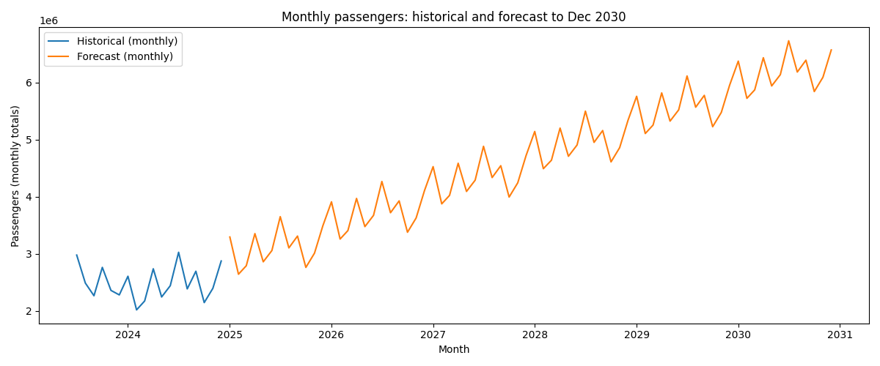

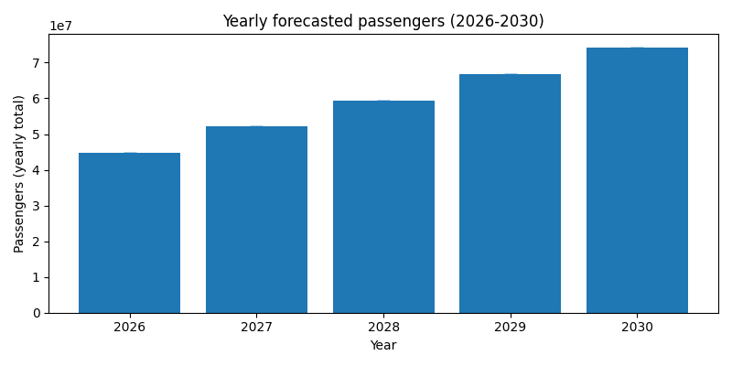

The numerical forecast results generated by the model show a clear and consistent upward trend in projected passenger volume from 2026 through 2030. In 2026, the terminal is expected to serve approximately 44.7 million passengers, increasing to 52.1 million in 2027, 59.5 million in 2028, and 66.9 million in 2029. By 2030, annual ridership is projected to reach 74.3 million passengers. The extremely narrow confidence intervals around each prediction indicate high model stability and strong confidence in the forecasted values. Overall, the Excel forecast results confirm robust year-over-year growth, underscoring the need for scalable and flexible temporary staging facilities capable of handling increasing passenger volumes over the next five years.
R